Paris Public Library
Board of Trustees
July 13, 2026
The regularly scheduled meeting of the Board of Trustees was called to order at 4:32 p.m. by Vice President Cherie Lehman. Brann, Garst, Gross, Lehman, Punzelt, Schneider, Boylan – present. Earlywine, Gill, McGill – absent.
Minutes of Previous Meeting: MOTION: Garst, second by Brann, to accept minutes from May 11, 2026, meeting to show Susan Punzelt as present. Motion carried.
Correspondence, communications, and public comments: None
Committee Reports:
*Finance: Librarian Boylan presented the following invoices that need to be submitted to the city for payment.
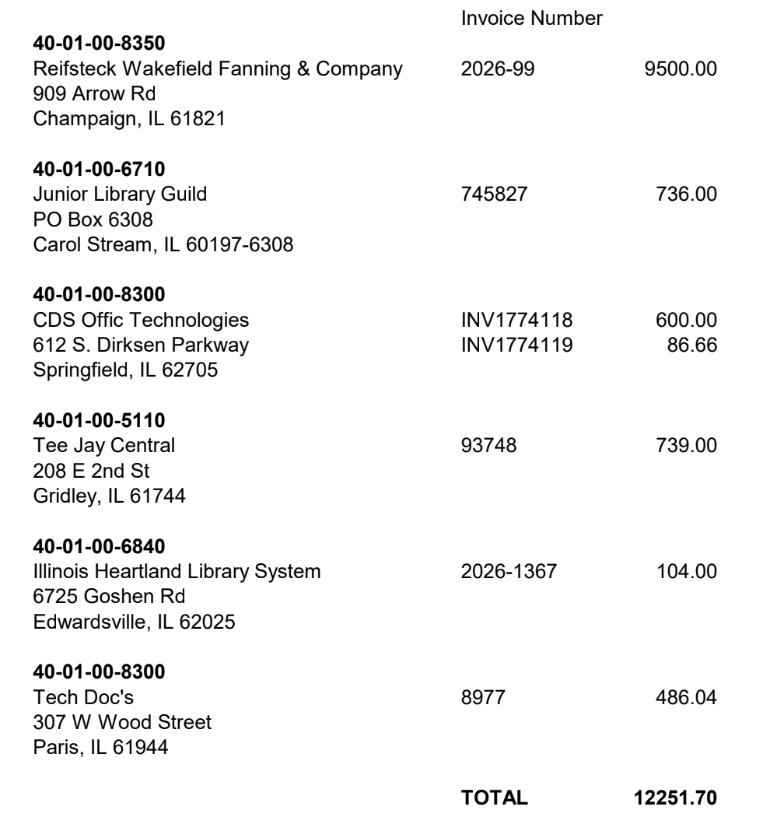
MOTION: Gross, second by Punzelt to approve the Finance Report. Motion carried.

*Book: None

House: A bathroom stall lock was replaced. Due to a theft of cash, an additional camera was installed to monitor the circulation desk.

The air conditioner was not working, and Aire Serv of Terre Haute was called to repair. MOTION: Punzelt, second by Brann to grant Librarian Boylan permission to spend $626.26 for the repair. Motion carried.
Librarian’s Report: The number of registered patrons has decreased for each of the last two years. This came to light during the preparation of the Illinois Public Library Annual Report (IPLAR). The library participated in the first Paris Pirate Fest by running and escape room and a scavenger hunt. It was great success. Sixty children signed up for the Summer Reading program. The annual book sale was held without the help of the Friends. The library was approached by Illiana Vision Connection about hosting support meetings for people experiencing vision loss. The remaining tech grant money was spent on a 3d printer which soon will be open to the public. People who wish to print will submit their files and will be charged based on the weight of filament used. Librarian Boylan reported on the success of the Roku sticks. MOTION: Gross, second by Schneider to subscribe to additional streaming services, Disney+, Hulu, and HBO, and to purchase the appropriate number of Roku sticks to support circulation. Motion carried. MOTION: Brann, second by Schneider to approve the Librarian’s Report. Motion carried.
Old Business: The proposal from Reifsteck Wakefield Fanning & Company to prepare competitive bidding documents for phase 1 of the renovation project including bidding documents, bidding phase services, and construction phase services was discussed. We want architects here on critical days. The wording needs to be changed to say that they will be onsite the appropriate number of times to ensure that work is completed correctly. MOTION: Lehman, second by Schneider to accept the fee proposal with those changes and to have Reifsteck Wakefield Fanning draw up the contract. Motion carried.
New Business: MOTION: Garst, second by Gross to maintain the current policy on non-resident cards. Motion carried.
MOTION: Gross, second by Brann to provide a 6.5% raise to all library staff. Motion carried.
Miscellaneous: Shakespeare in the Park, Merry Wives, is Friday, September 25.
Motion: Brann, second Punzeltr to adjourn. Motion carried. Meeting adjourned at 5:50p.m.

Next regularly scheduled meeting is Monday, August 10, 2026.
Respectfully submitted,
Cherie Lehman, Secretary pro tem

